PRESS INFORMATION
MARCH 2018
______________________________________________________________

TLC Plant moves up a gear with a Volvo EC27D

Established just 12 months ago by two young entrepreneurs TLC Plant has moved up a gear by adding a new Volvo EC27D compact excavator thanks to the continued demand for more and more work in the Devon locality.

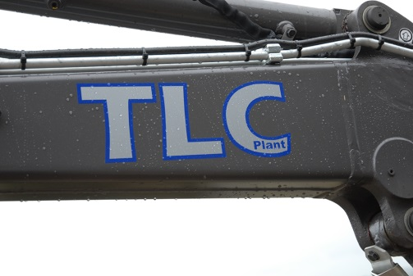
The new 2.7 tonne compact excavator was supplied following a successful demonstration by SMT GBs utility dealer for the south west of England Plant and Engineering Services. “We were looking to add a larger machine as our existing micro excavator has its limitations in terms of digging capacity so we rang around the obvious candidates,” explains co-partner Lewis Clarke. “It was Plant and Engineering Services who proved to be very pro-active in giving us an opportunity, to try a machine on demonstration then follow this up with a sensible quotation. Straight away we were extremely impressed with the Volvo EC27D - everything was just right – from the smoothness of the controls, the machine’s stability and the quality of build and so we had no second thoughts about placing the order,” he continues.
Joining a smaller 1.2 tonne micro excavator, the EC27D is powered by a Volvo 1.6 litre low emission Stage III engine coupled to a load sensing hydraulic system for optimum performance and fuel saving. Simultaneous control of slew and offset movements provides faster, more precise performance due to the right joystick control lever that features an electronically proportional roller. This allows the operator to accurately adjust hydraulic flow as needed. All hydraulic functions are performed in total independence for more control and less delay when handling multiple tasks. An automatic two-speed travel system engages when operating in high speed mode, automatically shifting gear from high to low according to the travel load. Another feature for increased efficiency is the standard auto-idling system that lowers engine speed to idle if a control is not used for five seconds. The engine reverts to the pre-selected speed almost instantly when any control is moved. This system delivers lower fuel consumption, longer engine life and less environmental noise.
The EC27D features Volvo’s industry-leading comfortable cab for less fatigue and more production. The ergonomically-designed cab offers greater leg and foot room, making it one of the most spacious in its category.
The new arrival will be used on general self-operated hire and will be deployed on groundworks, drainage and ditch maintenance, driveway construction and other related activities.
TLC Plant is located near Crediton and not far from Exeter and the main arterial routes connecting Devon and the West Country, The recently formed company is operated by business partners Lewis Clarke and Tom Lee.

Plant & Engineering Services of Beare near Exeter Ltd is the dealer for Volvo utility covering the south west of England.

SMT GB markets Volvo Construction Equipment products which include wheeled loaders, articulated haulers, hydraulic excavators, Volvo utility equipment and Volvo road equipment products in Great Britain. There are eight strategically placed customer support centres, a dedicated National Used Equipment Centre and a network of utility equipment dealers to ensure high quality customer support is maintained throughout the country.

Ends.

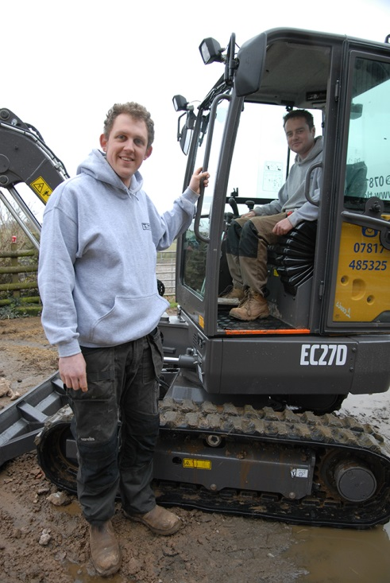
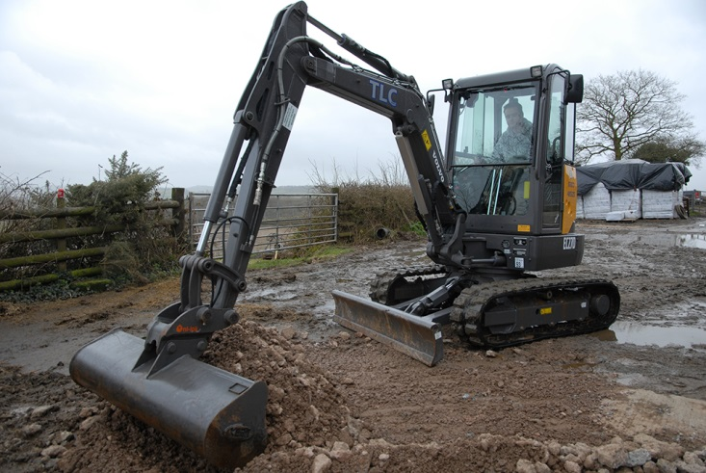
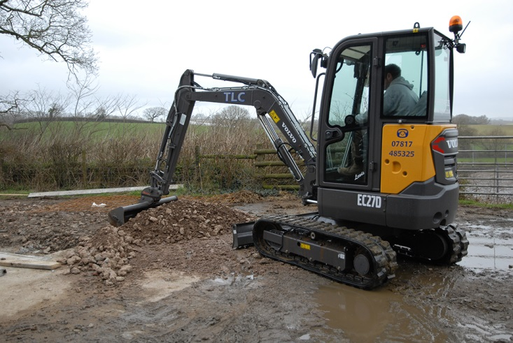

TLC’s partners Tom Lee (left) and Lewis Clarke at the controls

